What is driving this rapid adoption of APIs? The answer is a need for Speed and Reach. Businesses need to respond quickly to market demands and opportunities with little impact to their existing systems. Changes required supporting the latest innovations in Mobile or other mechanisms allowing customers to interact with the business cannot require changes to the back end systems that are running the business or it would cause the support to take too long to bring to market.

Businesses also want to extend their reach partnering with others to create value added applications that can be brought to market. Any single business only has so many programmers. Why not expand your work force with others outside the company to create new and innovative applications that send more business to you? This is accomplished by creating an API Economy where you choose to expose selected assets as APIs, which can be consumed by application developers who add further value, and subsequently make their application available to new customers. If this “supply chain” of assets provides value to the business, the app developer, and the end consumer, then we will be successful in reaching new markets that would not have been possible with a limited internal work force. This is not to say that making APIs available internally is not also important. We will cover many scenarios as entry points below.

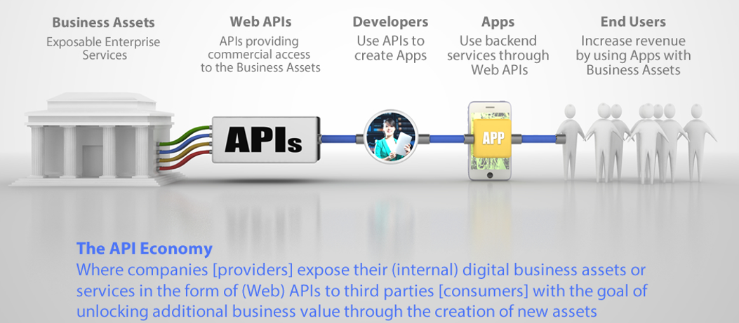
Figure 1 – API Economy Supply Chain

Business APIs (or Web APIs) perform the dual purpose of exposing selected assets for easy consumption and shielding back end systems from direct access where they might need changes at a rate that cannot be met. Surrounding the APIs are capabilities to make the APIs available, marketed, and easily found and consumed so that we don’t need that excess calls will raise alerts, but will not be stopped. Analytics as to how much their App has used the API are calculated based on the passing of the API key.

The DataPower appliance is part of the IBM API Management product. It is the run time gateway enforcement for APIs. The API calls are validated for security and consumption levels and the back end resources are invoked as defined. Returned data is formatter appropriately and returned to the calling App.

Note: in this scenario the data returned is not personal/confidential. ATM locations are open data and the same results would be provided to any consumer. If the scenario had been something personal, such as checking a specific customer’s account balance, then OAuth would have been used to pass the identity of the customer (App user) through the App into the system to ensure authentication and authorization to access this data.

The component interaction for the C&I Architecture would then be as follows:

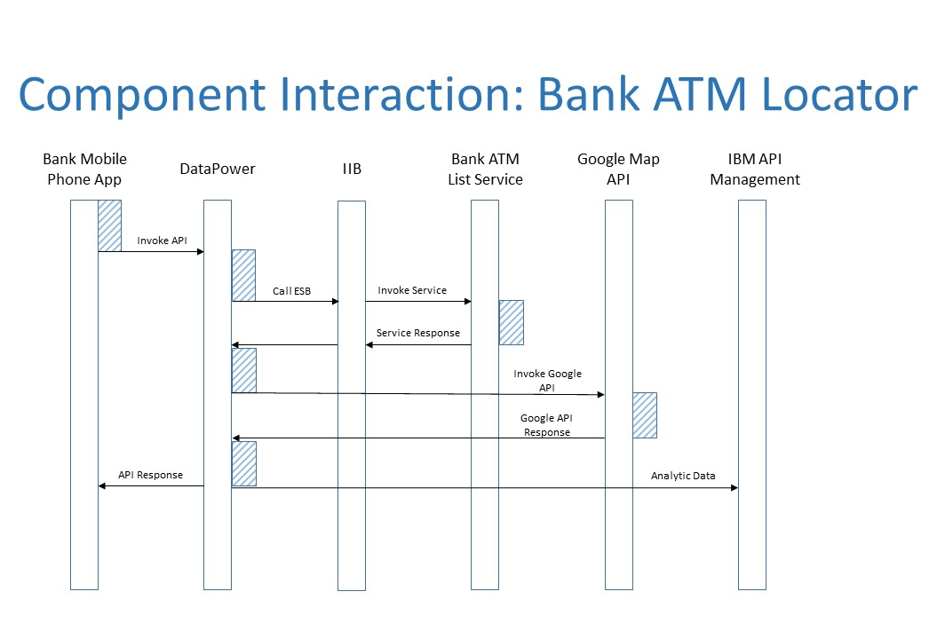
Note: this shows only the run time invocation of the API, not the creation and deployment.

